Prompt：Task Prompt: For this task, you need to transport a blue, hollow plastic box. Please move it from the starting point "Pick Station 2" to the destination "Place Station 3". Please follow the Standard Operating Procedure (SOP).
JCIIOT 2026 Standard Operating Procedure (SOP): Electronics Factory Material Handling Task
Task Name: Material Handling Task
Task Number: SOP-ELC-001-2026-GEN
Version: 1.0
Effective Date: April 23, 2026
Purpose: This SOP will guide you on how to safely and efficiently transport designated materials from a starting point to an end point. Please read carefully and follow all steps.

- Task Overview
Welcome to our electronics factory! You will be responsible for a critical material handling task. The core of this task is to move a specific type of material from a designated location (starting point) to another designated location (end point). During execution, please remain vigilant and pay attention to random changes and potential obstacles in the environment.
- Preparation Phase
2.1 Identify the Materials You Need to Handle
The goal of this task is to handle specific types of materials. Please confirm the materials to be handled according to the task prompts and carefully identify their characteristics.

- Operating Procedure:
Step 1: Proceed to the "Pick Station" (Starting Point)
- Please first navigate to the task's starting point: the Pick Station.
- Upon arrival, please look around to ensure the area is clear and tidy for your subsequent grasping work.
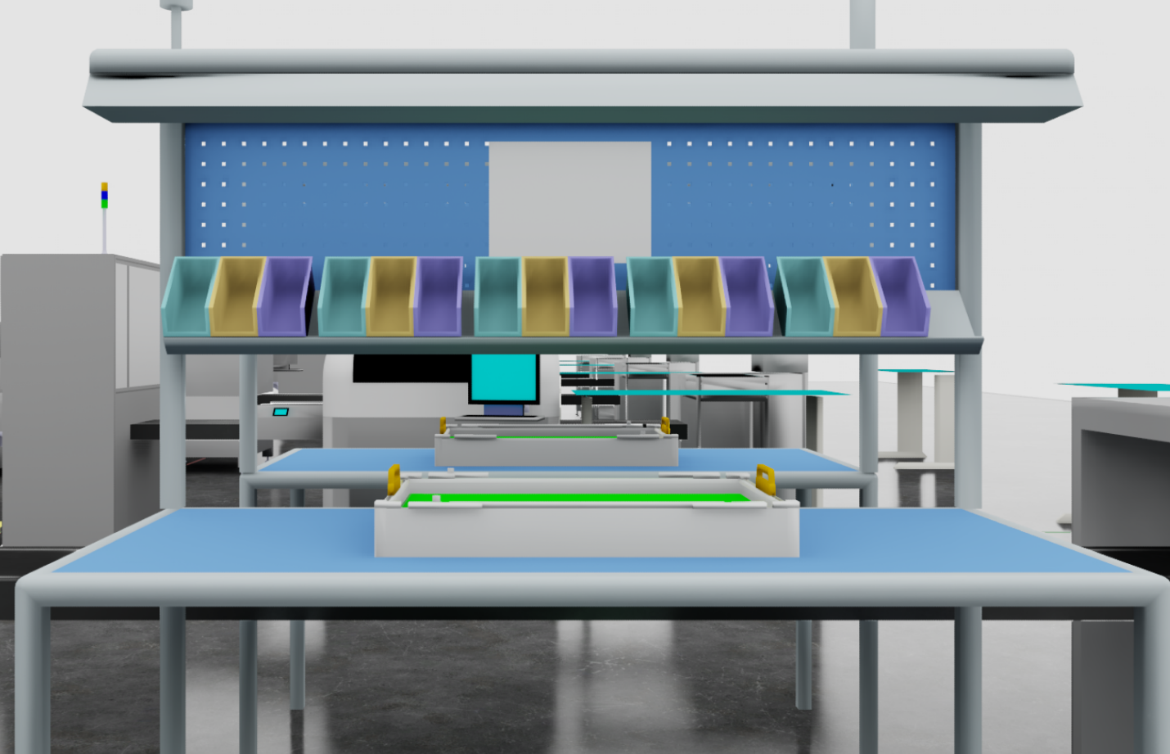
Step 2: Carefully Pick Up the Material
- At the Pick Station, you need to precisely identify and locate the target material.
- Before reaching out to grasp, plan your grasping path to ensure you do not touch any other materials or equipment nearby.
- Grasp the material with smooth, precise movements.
- Once firmly grasped, ensure the material is securely held to prevent it from slipping during transport.
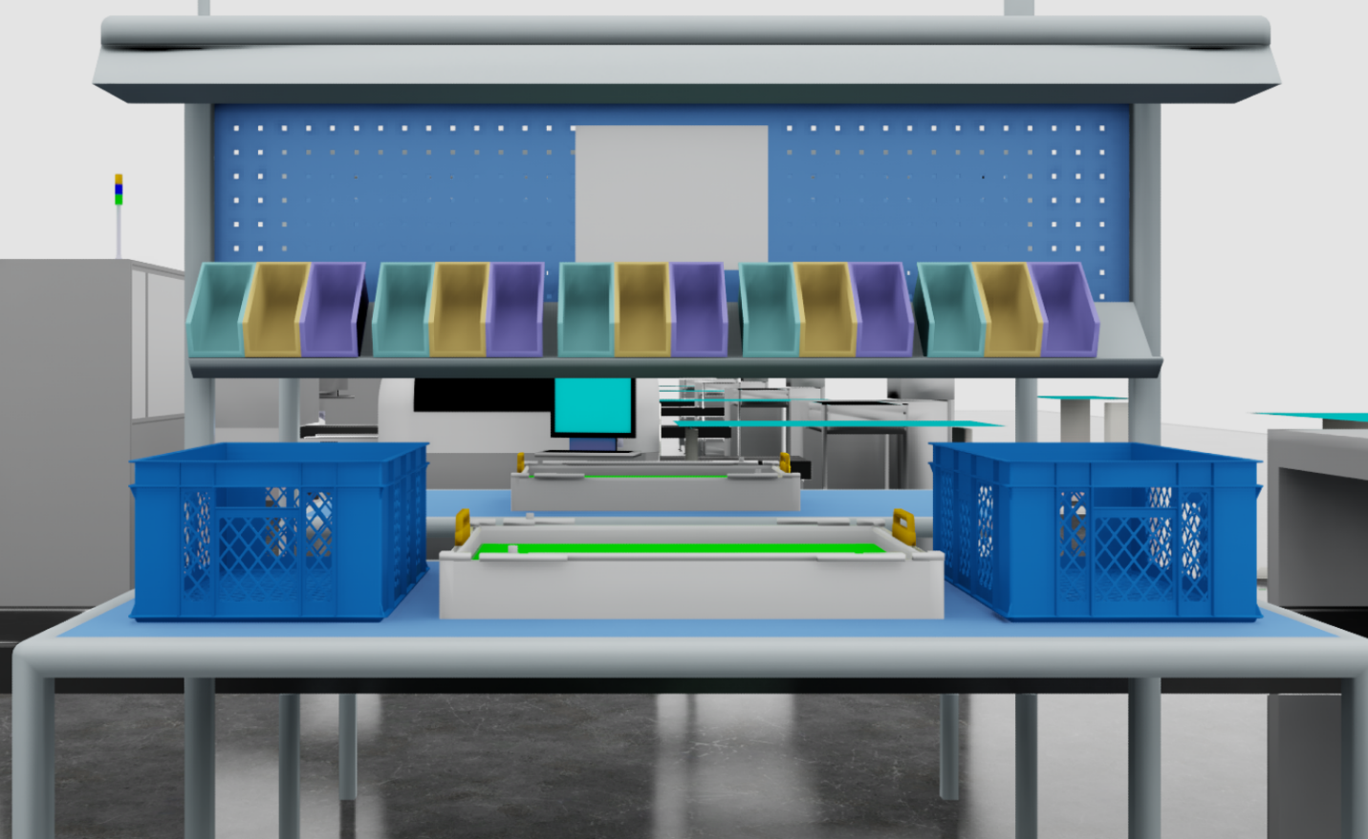
Step 3: Safely Traverse the Factory – Navigate to the "Place Station" (End Point)
- Now, plan the optimal path from the starting point to the end point. This path should be as short as possible, and also the safest, avoiding all potential hazardous areas.
- During movement, always remain vigilant! Obstacles may appear in the factory aisles, and you will need to dynamically adjust your path to skillfully avoid them.
- Please ensure that the material you are handling remains stable throughout the entire movement, avoiding violent shaking, dropping, or collision with the surrounding environment.
Factory Map:
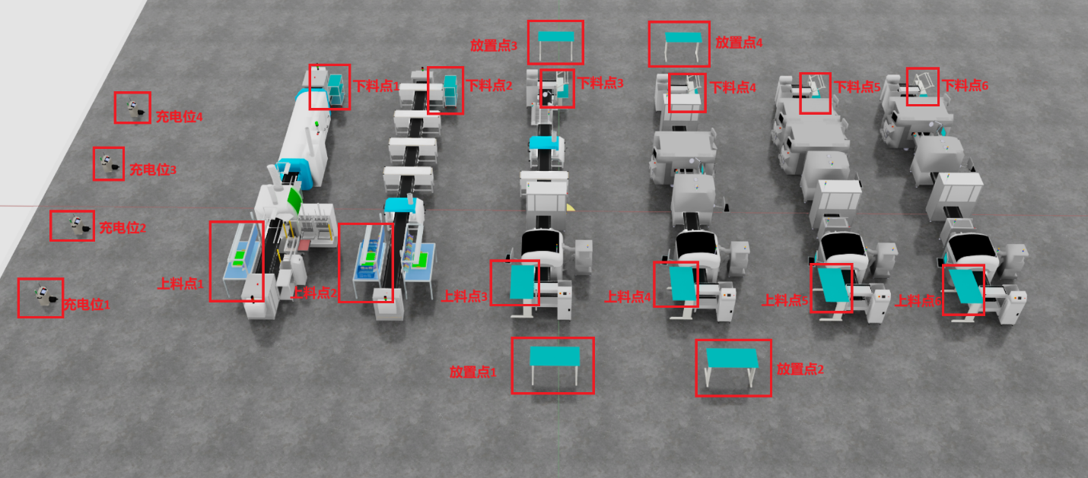
Place Station
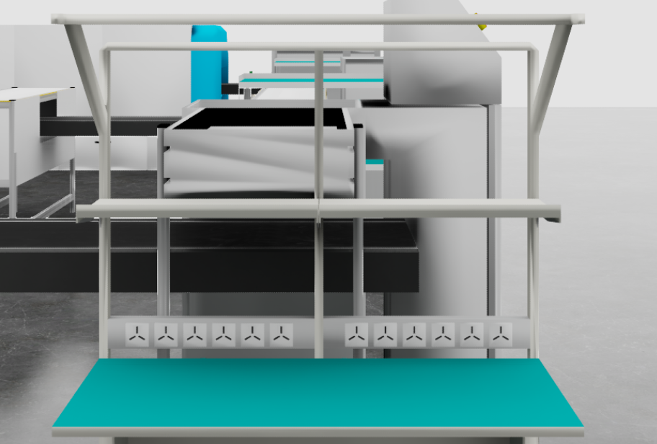
Step 4: Precisely Place the Material
- Upon reaching the Place Station, please reconfirm that there are no other obstructions in the placement area.
- Precisely place the material you grasped into the designated area within the Place Station. Ensure it lands smoothly, without tipping over or exceeding the designated range.
- Gently release the gripper, confirming that the material is fully detached and securely placed.
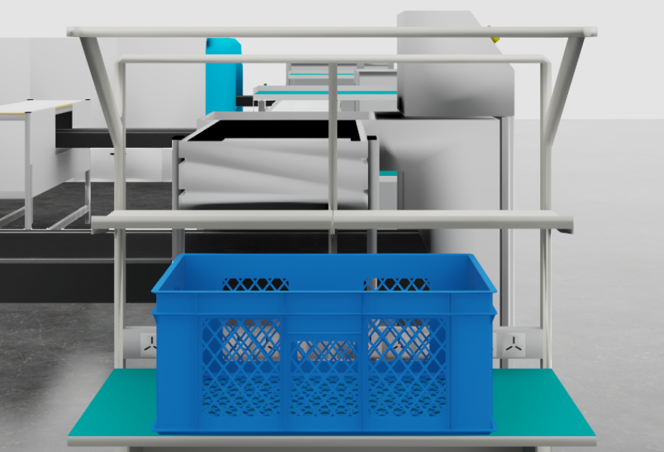
Step 5: Repeat Operation Until Task Completion
- If the task requires handling multiple materials, please return to Step 2 to continue picking up the next material.
- Repeat Steps 3 and 4 until all specified quantities of materials have been successfully transported and placed.

Step 6: Task Wrap-up
- After all material handling is complete, please return to the designated standby area, or prepare to execute the next task instruction.
- Please record the completion status of the task and any important data collected during its execution.

- Important Notes and Anomaly Handling
• What to do in an emergency? If an accidental collision occurs during movement or operation, immediately stop, and assess the situation. If possible, try to plan a new safe path; if you cannot resolve it yourself, report the anomaly promptly.
• Material dropped? If, unfortunately, material is dropped during transport, try to re-grasp it. If it cannot be safely re-grasped, report the anomaly.
• SOP and reality don't match? If you find any discrepancies between the description in this SOP and the actual environment, immediately stop operations and report it, awaiting further instructions.
• Safety First! At all times, always prioritize your own safety and the safety of your surroundings. Avoid any actions that could lead to damage or danger.

